* Linked list middle element

Take two pointers \*p1 and \*p2 pointing to the head of linked list

Start a loop and increment \*p2, 2 times (with null checks)

If \*p2 is not null then increment \*p1 1 time

When \*p2 reaches null; you have got the \*p1 at the center

* Array intersection

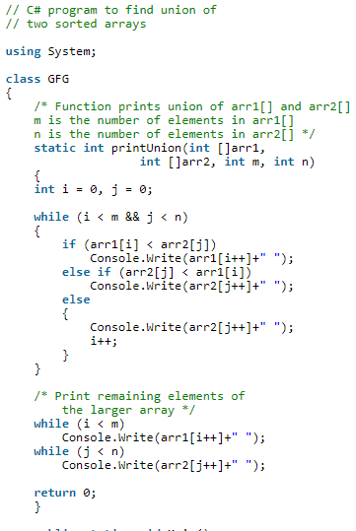

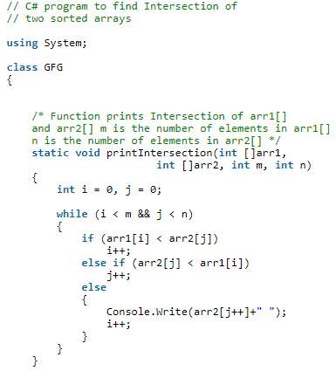

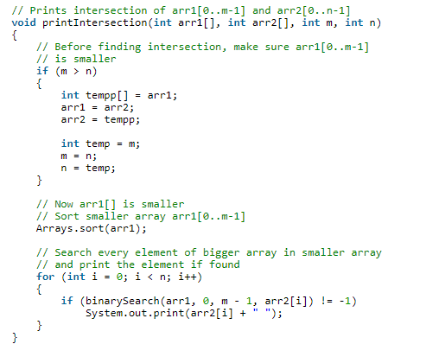

* String palindrome
* Delete specific element of link list from last
* Given a sequence of number find the missing

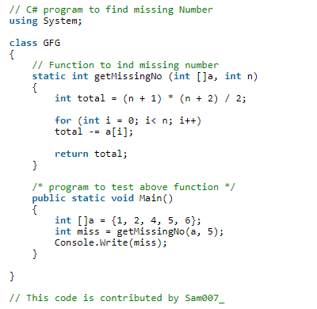

* Quick sort after one ittretion where will be pivot
* Recursive class equations
* 127.0.0.1 loop hole
* A ? true : false
* Char \*p1,p2
* BST complexity logn
* Two functions with f(n), g(n) then max(f(n),g(n)).
* 32bit system ek process ko kitni memory allocate hoti hy

